Student Name:

Class and Section COP 1334-2193-2679

**Due: February 13, 2019 11:59 pm**

**Project:** Population Growth

COP 1334 Introduction to C++ programming

Miami-Dade Community College – Kendall Campus

Problem Description:

# Using Files—Population Bar Chart

Write a program that produces a bar chart showing the population growth of Prairieville, a small town in the Midwest, at 20-year intervals during the past 100 years. The program should read in the population figures (rounded to the nearest 1,000 people) for 1910, 1930, 1950, 1970, 1990, and 2010 from a file. For each year it should display the date and a bar consisting of one asterisk for each 1,000 people. The data can be found in the People.txt file located in the [**Chapter 5**](https://jigsaw.vitalsource.com/books/9780134379371/epub/OPS/xhtml/fileP700101142400000000000000000287B.xhtml#P700101142400000000000000000287B) **Exercises** programs folder in Blackboard

Here is an example of how the chart might begin:

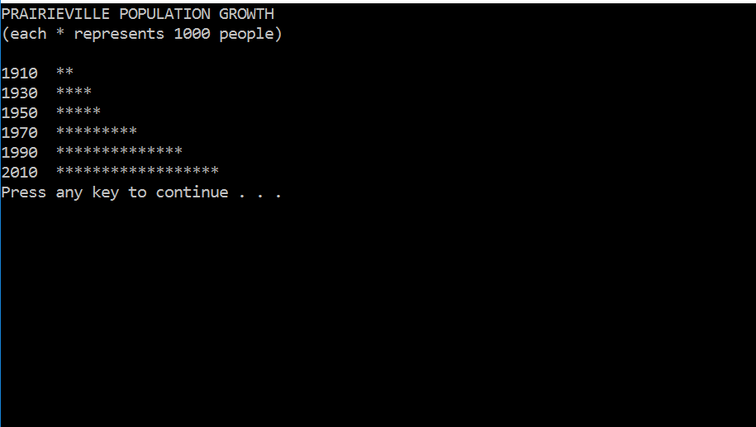

Analysis:

My project displays the amount of population of Prairieville using bar charts. The program uses the library of <fstream> to extract the amount of population from a file call “People.txt” **or create one by itself** so it’s not necessary to provide the .txt file. Then using those, it executes and condition that display the amount of population between years using bar charts (*).

Design:

I start including the libraries (pch.h, iostream and iomanip), the “std” namespace and

declare the main function. The next step was a brief introduction. Then I create my variables with its respective values in some cases **(I also include an array of numbers)**. Next was read the file using ifstream and gather the population ones validate if exist

the file People.txt, otherwise create a new one using <ofstream>. Then using “for” I loop to retrieve each value and divide these by 1000 to calculate the amount of “*” I’ve to display. Finally, I display the amount of “*” side by side of each year and close the file ones done.

Testing:

I mostly use the Error List tab after debug the program.

Submit the following items:

1. Email this Word file to [wmurill1@mdc.edu](mailto:wmurill1@mdc.edu) by 2/13/2019 11:59 pm
2. C++ source code file